|  |  |  |
| --- | --- | --- |
|  | Score | Criteria |
| Abstract | **2/5** | * **(1pt) Main theme of the experiment** * **(2pts) Explanation of the experiment** * **(2pts) Summary the discussion** |
| Introduction | **2/10** | * **(3pts) Explanation of the main concepts** * **(3pts) Relationship between the concepts** * **(4pts) Give broad context of this experiment** |
| Theoretical Background | **8/10** | * **(2pt) There is a equation about conservation of momentum.** * **(3pts) There are equations of motion.** * **(5pts) There is a mathematical definition of an impulse.** |
| Methods | **3/5** | * **(2pts) There are experimental parameters.** * **(3pts) There are important experimental steps.** |
| Results | **17/20** | * **(each -1pts) There is no axis lables with proper dimensions.** * **(each -3pts) Wrong data** * **(each -3pts) Wrong calculation** * **(each -5pts) There is no answer for a question.** |
| Discussion | **16/30** | * **(each -3pts) There is no quantitative and mathematical explanation about an answer.** * **(each -3pts) There is no quantitative and mathematical explanation of a systematical error.** * **(no point) There is no answer for a question.** |
| Conclusion | **4/10** | * **(3pts) Summary of the introduction and the theoretical background** * **(3pts) Summary of the experiment** * **(4pts) Summary of the discussion** |
| References | **10/10** | * **(each -1pt) If there is no proper reference.** |
| Total | **62/100** |  |

NAME Treepat Chantaurai

DATE 13 September 2021 Section J

**Report Sheet for Experiment 3: Conservation of Momentum and Impulse**

Abstract

In this experiment, the concept of conservation of momentum and its change during collision are e investigated. In the first section, carts with equal and unequal masses are attached and depress as an explosion, their velocities are collected for further studied to confirm the conservation of momentum, which turns out to be not true for this setup because there is a slight unequal force on each cart making on moving before the other. Inelastic and elastic collisions are done by attaching Velcro and Magnetic bumpers on the carts. Inelastic collision does not conserve kinetic energy but do with momentum, with slight change error caused by the energy lost from heat at Velcro. Elastic collision conserves both with some error which is similar for both equal- and unequal- masses, indicating the systematic error. Finally, bumper extends the collision time, thereby decrease the change in momentum which can be found by the area under force-time curve during collision, this results in a more elastic collision.

Introduction

Momentum or linear momentum is a vector property of a moving object, possessing a magnitude of product of mass and its velocity. With an applied force, it can be inferred to a change of momentum versus time as follows:

$$p = mv$$

$$F = \frac{dp}{dt}$$

Theoretical Background

In a case of no external force, a conservation of momentum is occurred because of the zero acceleration, therefore, same initial and final velocity. There are two types of interactions between objects, including, collision and explosion. Explosion is a separation of a big object (mass M, initial velocity U) into smaller pieces, for instance, mass m1 and m2 with final velocity v1 and v2, respectively. The conservation of momentum can be derived as:

$$MU = m1v1 + m2v2$$

On the other hand, collision can be categorized into elastic and inelastic one, distinguishing by whether the kinetic energy is conserved or loss. Macroscopic collisions will results objects converting kinetic to internal energy, so no large-scale collision is perfectly elastic. The conservation of momentum and kinetic energy of two objects with mass m1, m2 and initial velocity u1, u2 can be shown below. However, Inelastic condition will not conserve the kinetic energy.

$$m1u1 + m2u2 = m1v1 + m2v2$$

$$1/2 m1u1^2 + 1/2 m2u2^2 = 1/2 m1v1^2 + 1/2 m2v2^2$$

The change of momentum can be defined as impulse (I) which is the integral of force over a period of time as follows:

$$I = mv - mu= \int_{0}^{t}{F dt}$$

Therefore, a property of bumpers using to damp the collisions of two objects investigating in this experiment can be described with how long the collision occurred and what the maximum force is.

Methods

1. Setup smart carts as depicted in Figure1 with magnet attached and graph the velocity vs. time. Calibrate the velocities sign so than both are positive to the right.

A – Explosion

1. Depress the plunger on one cart to the other
2. Start recording the data and tap the trigger to release them
3. Add mass bars to one of the smart carts and repeat step 2 and 4

B – Inelastic Collision

1. Place two carts with Velcro bumpers facing each other
2. Start recording the data and push one of the carts to collide with the others
3. The initial velocity of the non-moving cart is zero, the final velocities of two carts are the same
4. Add mass bars to one of the smart carts and repeat step 5 and 6

C – Elastic Collision

1. Place two carts with magnetic bumpers facing each other
2. Repeat step 6 to 8

D – Impulse

1. Add the force sensor to the cart with spring attached as shown in Figure2
2. Compress the cart and start recording the data
3. Hit the plunger release
4. Graph between velocity, force versus time and find area under force-time with Peak curve-fitting in Origin Lab Software
5. Repeat step 11 to 13 with other bumpers including rubber and magnet.

Results

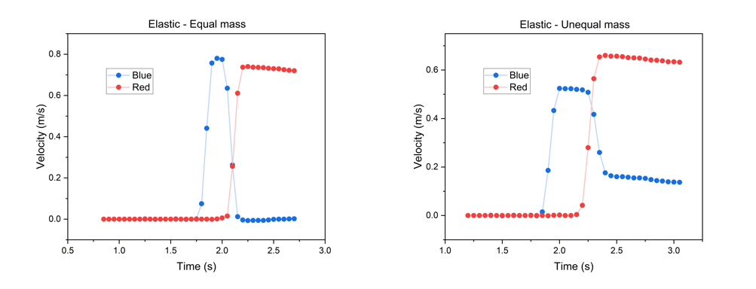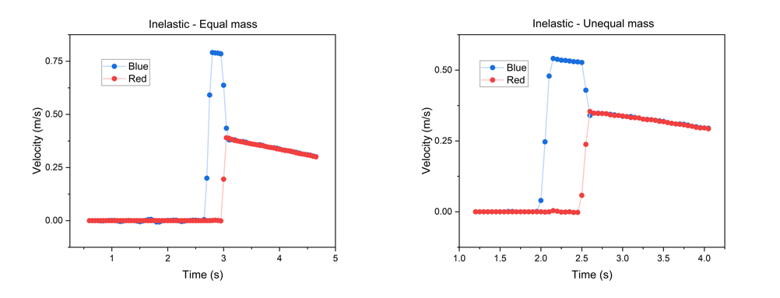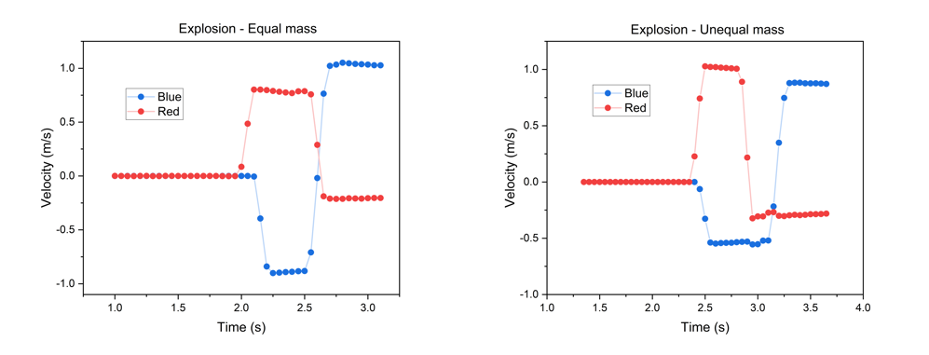

a

b

c

d

e

f

Figure 1 displays relationship between velocity vs time with of blue and red smart carts of equal and unequal mass. a-b) explosion of the two c-d) inelastic collision and e-f) elastic collision between the two carts.

|  |  |  |  |  |  |  |  |  |  |  |
| --- | --- | --- | --- | --- | --- | --- | --- | --- | --- | --- |
| Experiments | | Mass (kg) | Velocity (m/s) | | Momentum (kgm/s) | | %change | Kinetic Energy(J) | | %change |
| Before | After | Before | After | Before | After |
| Explosion -Equal mass | Red | 0.2517 | 0 | -0.897 | 0 | -0.2801 | - | 0 | 0.17957 | - |
| Blue | 0.2497 | 0 | 0.792 |
| Explosion -Unequal mass | Red | 0.5081 | 0 | -0.543 | 0 | -0.2220 | - | 0 | 0.20378 | - |
| Blue | 0.2497 | 0 | 1.016 |
| Inelastic – Equal mass | Red | 0.2517 | 0.788 | 0.381 | 0.19859 | 0.19128 | -3.68 | 78.146 | 0.3649 | -53.31 |
| Blue | 0.2497 | 0.001 | 0.382 |
| Inelastic – Unequal mass | Red | 0.5081 | 0.532 | 0.348 | 0.27031 | 0.26347 | -2.53 | 71.902 | 0.4580 | -36.30 |
| Blue | 0.2497 | 0 | 0.347 |
| Elastic – Equal mass | Re | 0.2517 | 0.78 | 0 | 0.19633 | 0.18203 | -7.28 | 76.567 | 0.66350 | -13.34 |
| Blue | 0.2497 | 0 | 0.729 |
| Elastic – Unequal mass | Red | 0.5081 | 0.523 | 0.16 | 0.26574 | 0.24535 | -7.67 | 60.490 | 0.6039 | -13.09 |
| Blue | 0.2497 | 0 | 0.657 |

Table 1 summarizes the experiments, mass, before and after values of velocity, momentum, and kinetic energy. Percent change of momentum and kinetic energy are also concluded

c

b

a

Figure 2 displays the velocity and force vs time of three dumper materials including a) Rubber b) Magnet c) Spring

|  |  |  |  |  |  |  |  |
| --- | --- | --- | --- | --- | --- | --- | --- |
| Bumper materials | Velocity (m/s) | | Momentum (kgm/s) | | Momentum  change(kgm/s) | Impulse (Ns) | %Difference |
| Before | After | Before | After |
| Rubber | 0.587 | -0.378 | 0.149 | -0.096 | -0.2444 | -0.2516 | 2.94 |
| Magnet | 0.641 | -0.610 | 0.161 | -0.154 | -0.3149 | -0.3632 | 15.36 |
| Spring | 0.650 | -0.626 | 0.179 | -0.172 | -0.3513 | -0.0395 | -88.77 |

Table 2 summarizes the before and after velocity, momentum; and their changes, and Impulse calculated from peak curve-fitting of three bumper materials including Rubber, Magnet, and Spring. The percent difference between measured momentum changes and calculated impulse is also analyzed.

Discussion

In Figure 1, the data of velocities versus time are plotted for each type of explosion and collisions. Furthermore, useful properties, including, velocities, momentums, and kinetic energies are summarized in Table 1.

In an explosion, both initial velocities and kinetic energies of both objects are zero because they are in stationary. It is observed that there are increments in both the momentum and kinetic energy after the explosion as there are some external forces while releasing the two carts, which the theory suggests that despite this, they should be conserved. Also, the error might cause from the non-simultaneous beginning of each smart carts that the red cart starts moving first (has a change in velocity first even in an equal mass situation) which will result in the other cart (blue) experiences a slightly higher force.

In an inelastic collision, both equal mass and unequal mass collisions confirm the conservation of momentum where the momentum change is in an acceptable range of less than 5%. The kinetic energy, on the other hand, was lost up to 50% after the collision. The error deviated from the conservation of momentum might come from the heat occurring when the Velcro bands scrubbing one another.

Furthermore, in elastic collisions, the both momentum and kinetic energy are conserved in both equal- and unequal- mass, as theoretically suggested – from the Table 2. It is worth noted that the 7% change in the momentum might results from the systematic error of the setup because of the consistency between two cases. The kinetic energy differences are as well go in the similar manner, of approximately 13% but almost the same for the two cases.

Finally, during the collisions with three dumper materials, there is a slight decrease in momentum because the kinetic energy is lost from the collision with the bumper. With graph of force versus time, the impulse (change in momentum) can be calculated and compared with the change of momentum measured and multiplied with mass. It is done by integrating the area under F-t peak during the collision. The longer the collision occurs, the more energy will be conserved, it will be more of an elastic collision, indicating the property of the bumper. Rubber, spring, and magnet have collision (impact) time of 0.0135, 0.0625, and 0.0850 seconds, respectively. This trend goes along well with the increase in momentum change as the concept has been described above. The fitted impulse, however, does not agree with this, specifically with the spring bumper experiment. Not only that the difference between the change in momentum is tremendous, but that value deviates largely from the impulse (88.77% difference). This might cause from the place where the string and force sensor are placed, so that only the inertia will be considered regardless of the potential energy from the spring (or any other bumper materials)

Conclusion

In the first sets of experiment, it is shown that in an explosion, both the momentum and kinetic energy are not practically conserved as supposed because of the additional force at the very beginning of the explosion, making the two carts start moving at different time. Elastic and elastic collisions are supposed to conserve momentum but only the latter one will not conserve kinetic energy. The results from the experiment have confirmed that with the error coming from either heat during collision or friction from the trial. Lastly, the ‘good’ bumper extends the collision time, thereby decrease the change in momentum which can be found by the area under force-time curve during collision, this results in a more elastic collision.

Reference

1. https://genphylab.kaist.ac.kr/labs/general-physics-lab-1/conservation-of-momentum-and-impulse/manual